**SOFTWAREREQUIREMENT**

**SPECIFICATIONS**

On

**“ATTENDANCE**

**MANAGEMENT**

**SYSTEM”**

**SUBMITTEDTO**

**Mrs. Jayanti Dasana**

**By**

**Devi Prasad Mishra...........................................20051958**

**Anjali Shukla...............................................................20051968**

**Rishab Innani.............................................................20051955**

**Santosh Kumar Sah.........................................20051990**

**Pratham Sharma..................................................20051966**

**Sushil Sah Sudi........................................................20051944**



SCHOOL OF COMPUTER ENGINEERING

KALINGA INSTITUTE OF INDUSTRIAL TECHNOLOGY

# Table of Contents

**Table of Contents.................................................................................................................**

1. **Introduction..................................................................................................................... 1**
   1. Purpose.................................................................................................................. 1

1.2 Scope..................................................................................................................... 1 1.3 References............................................................................................................. 2

1. **General Description.................................................................................................... 3**
   1. Product Perspective.............................................................................................. 3
   2. Product Functions................................................................................................. 3
   3. User Characteristics.............................................................................................. 4
   4. Assumptions and Dependencies........................................................................... 4
2. **Specific Requirements................................................................................................ 5**
   1. **External Interface Requirements**........................................................................ 5
      1. User Interfaces.................................................................................................. 5
      2. Hardware Interfaces.......................................................................................... 5
      3. Software Interfaces........................................................................................... 5
      4. Communications Interfaces
   2. **Functional Requirements....................................................................................... 6**
      1. User Authentication and Role-based Access.................................................... 6
      2. Student Registration and Profile Management................................................. 6
      3. Recording Student Attendance......................................................................... 6
      4. Viewing Attendance Reports............................................................................ 6
      5. Generating Attendance Reports........................................................................ 6
      6. Automated Notifications.................................................................................. 6
      7. Faculty Management........................................................................................ 7
   3. **Non-Functional Requirements............................................................................. 7**
      1. Performance...................................................................................................... 7
      2. Security............................................................................................................. 7
      3. User Interface................................................................................................... 7
      4. Availability....................................................................................................... 7
      5. Scalability......................................................................................................... 7
   4. **Use Cases.................................................................................................................... 8**
      1. Student Process................................................................................................ 8
      2. Administrator Process ..................................................................................... 8
3. **Analysis Models................................................................................................................ 9**
   1. Class Diagrams........................................................................................................ 9

4.2 Activity Diagram..................................................................................................... 9 4.3 ER Diagram............................................................................................................ 10

1. **Appendices…................................................................................................................... 11**
   1. Appendix................................................................................................................ 11

**1. Introduction**

The Student Attendance Management System is a software (Web App) application designed to automate and simplify the process of recording and managing student attendance in educational institutions. The system aims to provide an efficient and accurate way to track student attendance, generate attendance reports, and facilitate communication between students, teachers, and administrators.

* 1. **Purpose:**

Introducing a comprehensive Attendance Management System (AMS) that amalgamates QR code scanning, location tracking, and manual input to redefine attendance tracking. Designed to optimize engagement and streamline administrative tasks, the system offers a multifaceted approach to attendance management. Attendees effortlessly scan QR codes for real-time check-ins, while the integration of location tracking ensures physical presence at the designated venue. For flexibility, instructors can manually input attendance data.

The AMS empowers administrators with an intuitive dashboard, delivering real-time insights, attendance trends, and data export capabilities. This innovative solution caters to varied preferences and scenarios, facilitating accurate attendance records and enhancing overall efficiency. By synergizing these cutting-edge features, the AMS delivers a comprehensive and adaptable solution for modern attendance tracking requirements in educational institutions.

* 1. **Scope:**

The Student Attendance Management System will encompass the following features:

* User authentication and role-based access control.
* Student registration and profile management.
* Recording student attendance for classes manually or by QR codes.
* Viewing individual and class attendance reports.
* Automated notifications to students and guardians about attendance.
* Faculty management of attendance and related tasks.

**1**

**1.3. References**

* A Review on Attendance Management System" by Sonali S. Pathak and Dr. S. R. Suralkar - This paper discusses various aspects of attendance management systems
* Attendance Management" by Jeffrey L. Buller - Offers guidance on managing attendance in educational institutions
* Online Communities and Forums: Websites like Reddit, Quora, or specialized HR and education forums often have discussions and recommendations related to attendance management systems

2

**2. General Description**

* 1. **Product Perspective**

The product Attendance Management system, is an independent product and does not depend on any other product or system. The product will automate various tasks associated with handling student details and better organizing the stored information and optimum performance. Thus, helping the colleges to ensure smooth working of these processes.

* 1. **Product Functions**

Our system has two types of accessing modes.

* + 1. Administrator
    2. User

A. Student

B. Teacher

**2.2.1 Administrator:**

AMS is managed by the Administrator. Administrators have to update and monitor the registered student details, add a new student, provide a register number for all students, assign each student a course etc. Administrator can update his profile, and also can give help to the teachers and students.

* + 1. **User:**

There are two users:

**A. Student:**

Users can only view their personal details, course assigned. and edit their assigned course and can view their attendance.

**B. Teacher:**

Users can add them onto the portal and view their schedules, mark attendance of the students, also can view the student details in graphical order, also of a single student and about the views from the students.

3

**2.3 User Characteristics**

This software gives access to two kinds of users.

* + - * 1. **Administrator:** The personnel and college administrator will have administrator access to add, delete and modify information stored in the database.
        2. **Authorized User:** Teaching staff will have access to only view the data stored in the database and can update the students attendance in the form of formatted reports.

**2.4 Assumptions and Dependencies**

* We assume that the office personnel do all the data entry based and the correct values obtained from forms and registers.
* We assume that the computers that will use the software will be part of the college LAN.
* Users with administrator access should be careful in deleting or modifying any information knowingly or unknowingly which will lead to inconsistency of the database.

The end users of this software are to have a basic level of computer knowledge i.e., point and click.

4

# 3. Specific Requirements

**3.1 External Interface Requirements**

**3.1.1 User Interfaces:**

● Web app along with meaningful web pages

● Reports are generated as per the requirement

**3.1.2 Hardware Interfaces:**

|  |  |
| --- | --- |
| ● Hardware Environment | Dual Core 2nd Generation |
| ● System Configuration | RAM-512MB HDD-80GB |
| ● Operating System | Windows XP |

**3.1.3 Software Interfaces:**

|  |  |
| --- | --- |
| Front End | HTML / CSS / JavaScript |
| Back End | JAVA / MySQL |

When invalid inputs are given to the modules then the error messages will be popped up in order to inform the user that the input provided is not taken by the database. When incomplete information is provided by the user and the user tries to submit the form in order to store the details in the database the system will pop up a message box asking the user to enter all the details required.

### 3.1.4 Communications Interfaces:

The machine will have to be part of the college Local Area Network to access the central database.

5

## 3.2 Functional Requirements

**3.2.1 User Authentication and Role-based Access:**

* Users (students, faculty, and administrators) must log in using their unique credentials.
* Different user roles: Student, Faculty, and Administrator.
* Role-based access control to ensure proper data access and manipulation.

#### 3.2.2 Student Registration and Profile Management:

* Students can register by providing necessary details such as name, student ID, contact information, etc.
* Students can update their profile information.

#### 3.2.3 Recording Student Attendance:

* Faculty members can mark students as present or absent for specific classes.
* Attendance can be recorded for various subjects and class periods.

#### 3.2.4 Viewing Attendance Reports:

* Students can view their individual attendance history.
* Faculty can view attendance records for their respective classes.
* Attendance records can be filtered by date, subjects, and classes.

#### 3.2.5 Generating Attendance Reports:

* Students can generate reports showing their attendance for a specific time period.
* Faculty can generate class attendance reports for evaluation and record-keeping.

#### 3.2.6 Automated Notifications:

* Students and guardians should receive automated notifications about student attendance (e.g., absence alerts).
* Faculty and administrators can receive notifications for unusual attendance patterns.

**6**

#### 3.2.7 Faculty Management:

* Faculty members can manage attendance records for their assigned classes.
* Faculty can update attendance records in case of mistakes.

## 3.3 Non-Functional Requirements

**3.3.1 Performance:**

* The system should handle a significant number of users simultaneously without performance degradation.
* Response times for generating reports and recording attendance should be optimal.

### 3.3.2 Security:

* Student data and attendance records must be securely stored and accessed only by authorized users.
* Passwords must be securely hashed before storage.

### 3.3.3 User Interface:

* The user interface should be intuitive and user-friendly, catering to users with varying levels of technical expertise.

**3.3.4 Availability:**

* The system should have high availability, with minimal downtime for maintenance and updates.

**3.3.5 Scalability:**

* The system architecture should allow for easy scalability to accommodate future expansion.

**7**

## 3.4. Use Cases

### 3.4.1 Student Process:

**3.4.2 Administrator Process:**

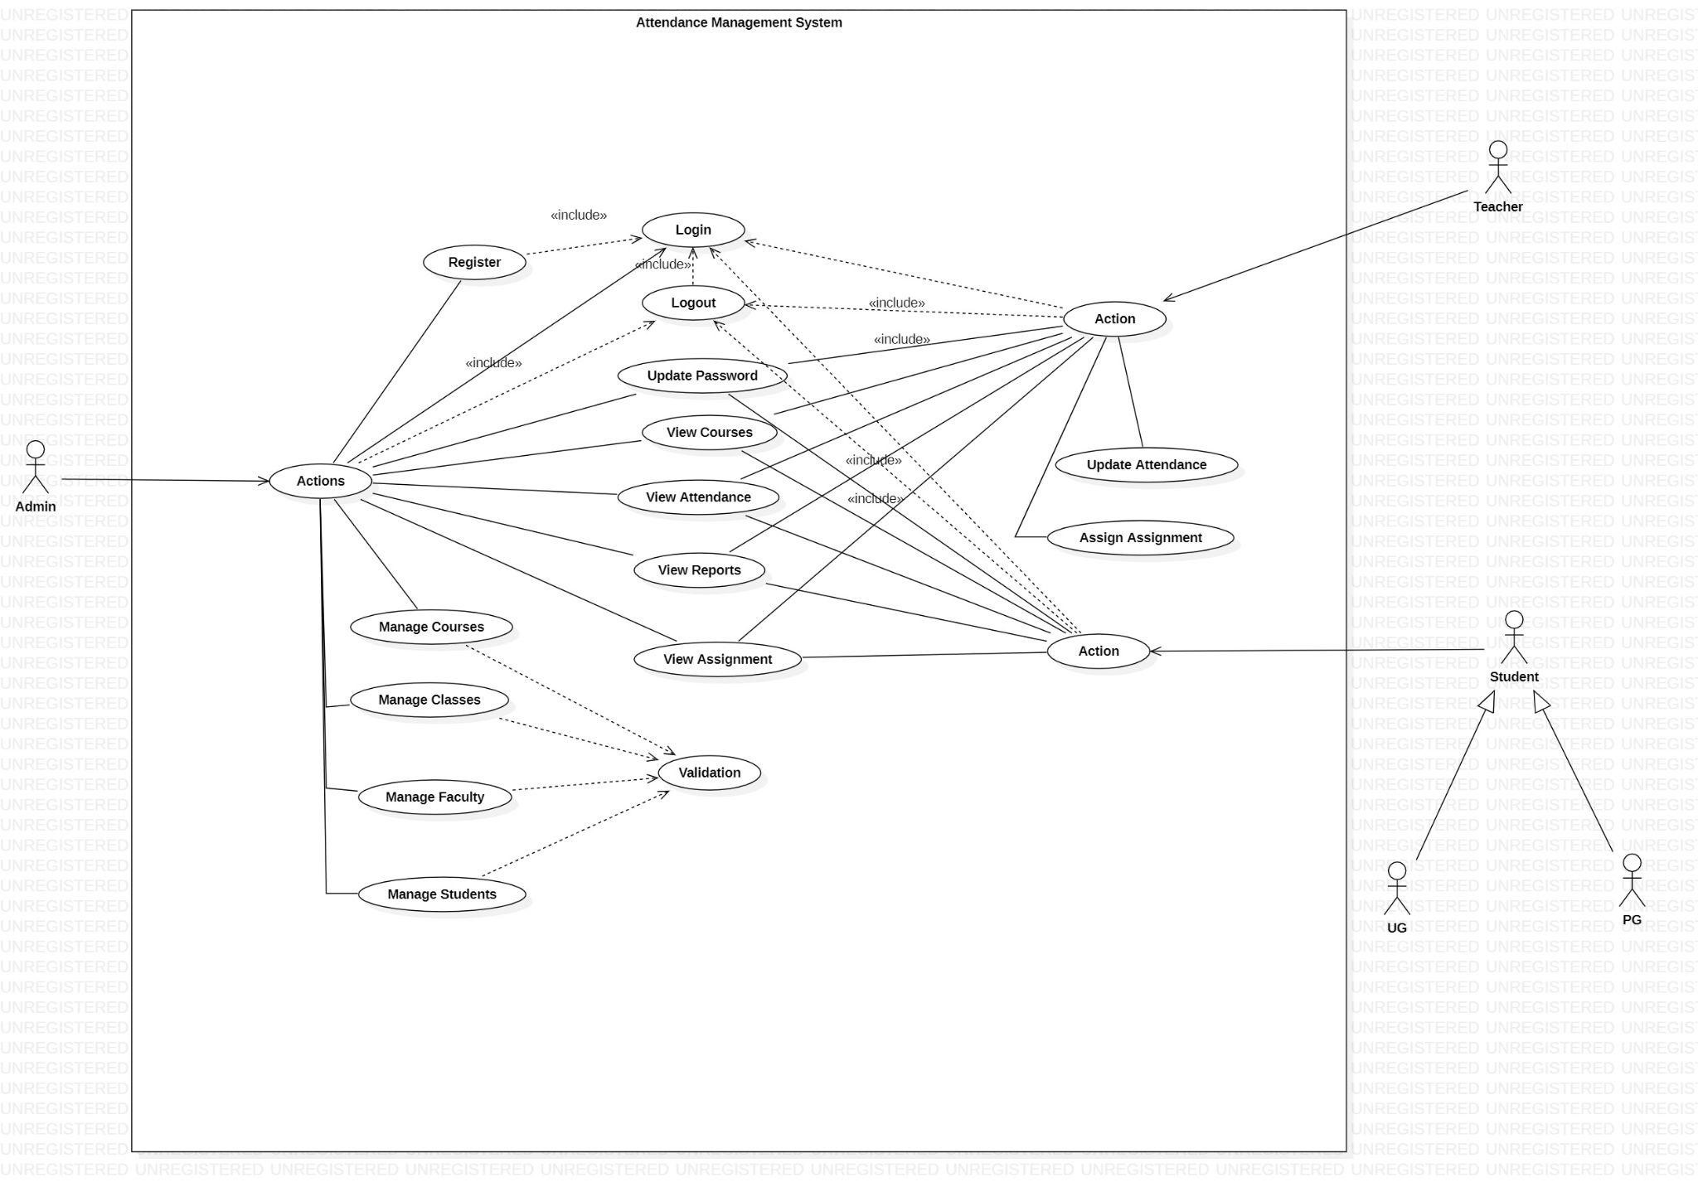

**8**

1. **Analysis Models**

**4.1 Class Diagrams**

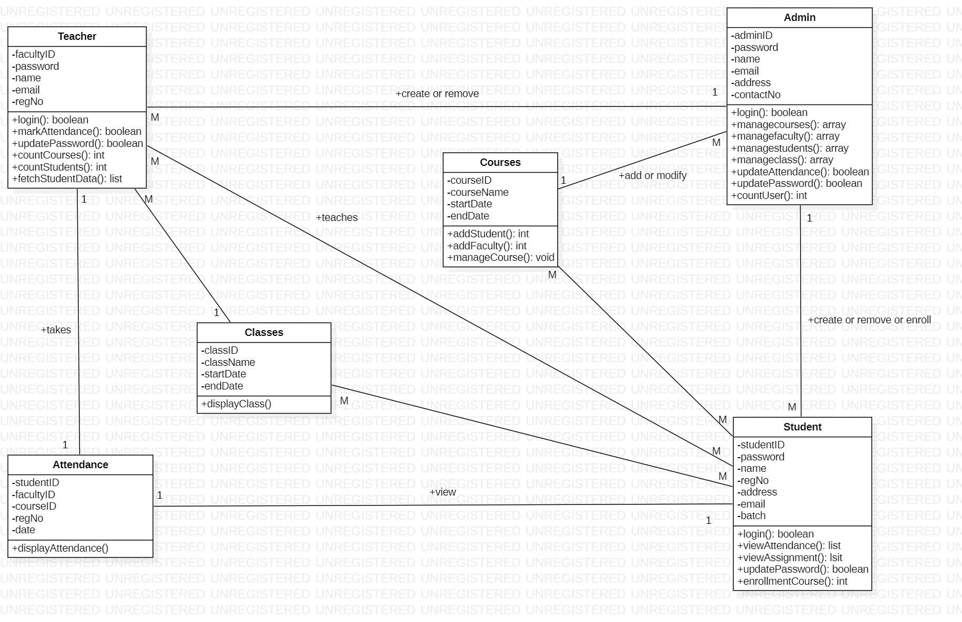

## 4.2 Activity Diagram

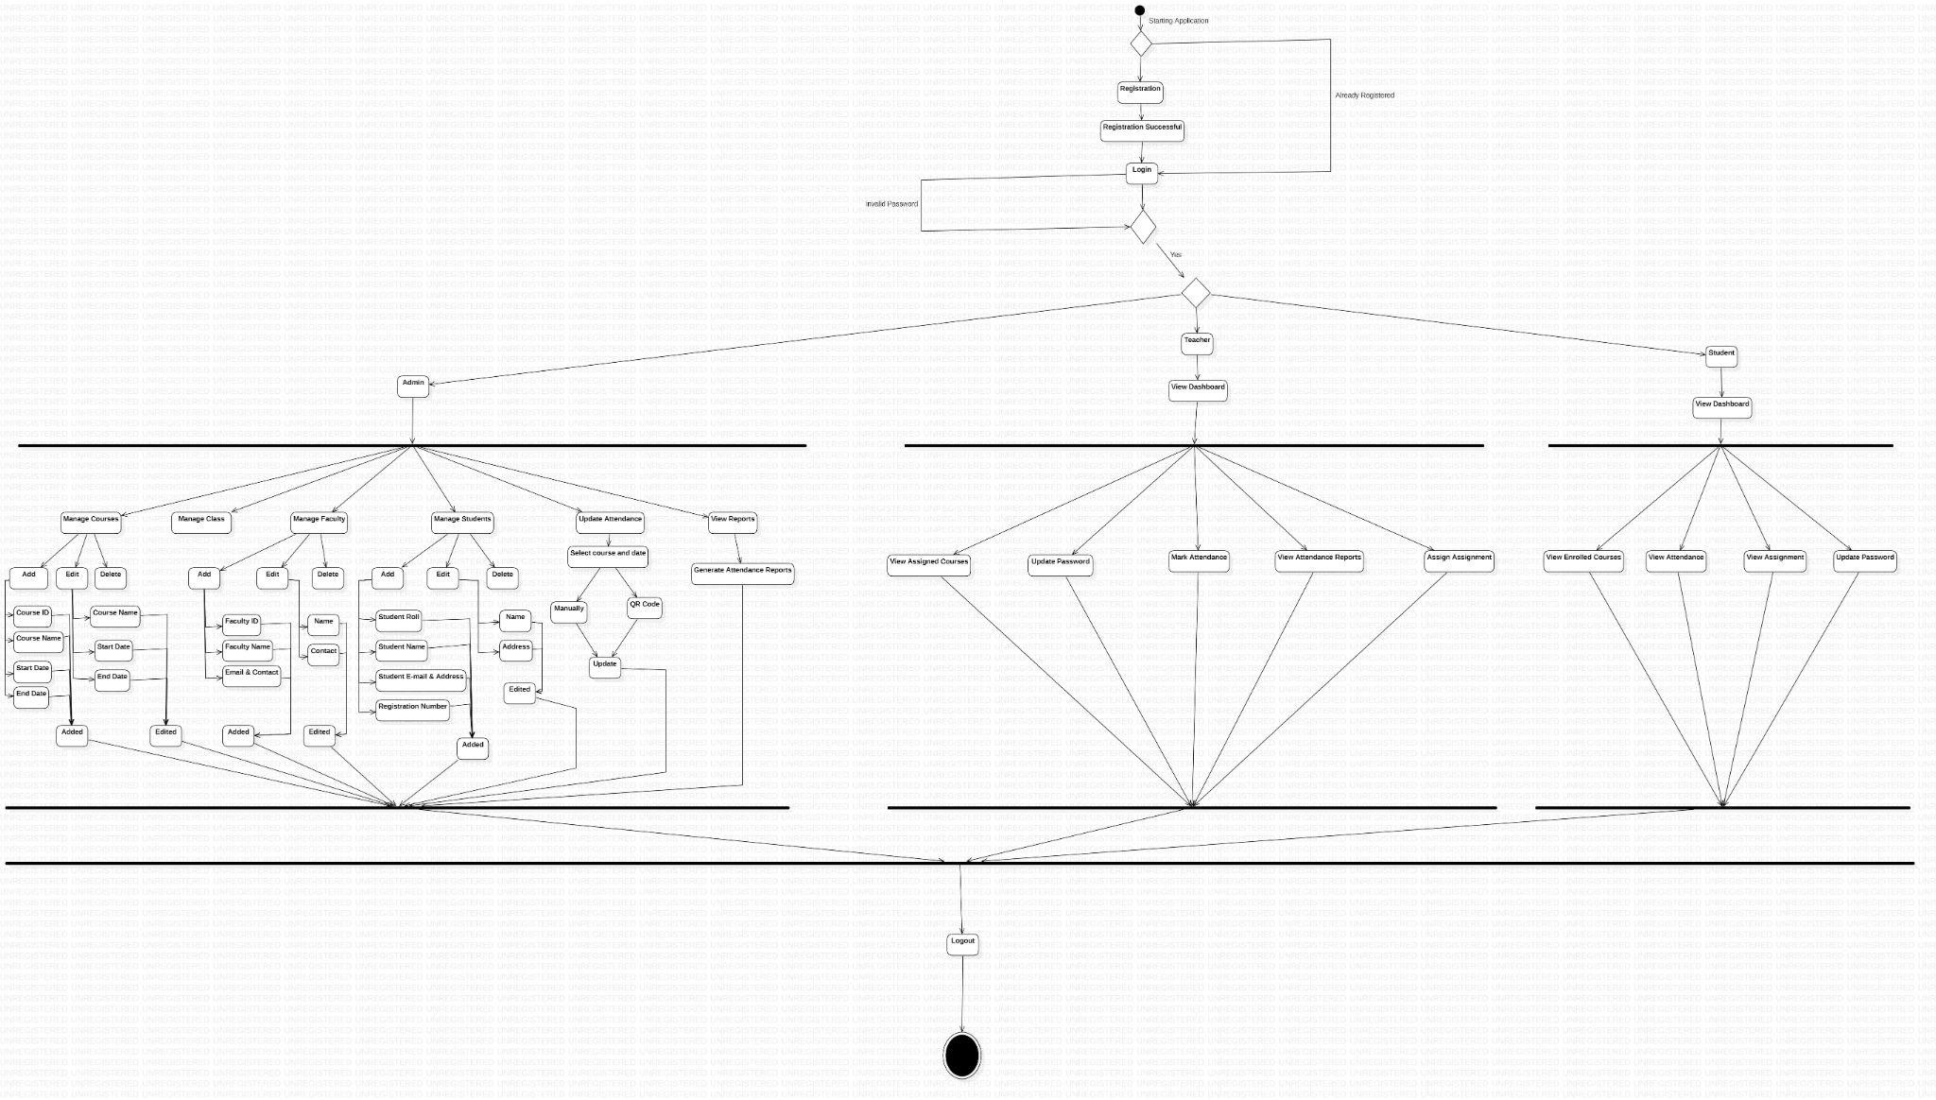

**9**

## 4.3 ER Diagram

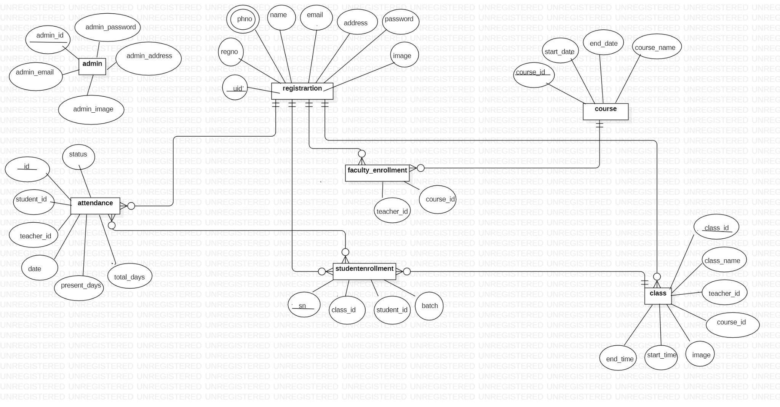

**10**

**5.Appendices**

**Appendix: Glossary**

Following abbreviations have been used throughout this document:

ERD : Entity Relationship Diagram

SRS : Software Requirement Specification

SQL : Structured Query Language

AMS : Attendance Management System

LAN : Local Access Network

QR : Quick Response Code

**11**